
Rossmoyne Senior High School
HUMAN BIOLOGY
Unit 3

Name: ___________________________________________________________________________

Circle Teacher: Rafei Ferrara Panzich Johansen Williams

TIME ALLOWED FOR THIS PAPER

Reading time before commencing work: Ten minutes
Working time for the paper: Three Hours

MATERIALS REQUIRED/RECOMMENDED FOR THIS PAPER
To be provided by the supervisor:
- This Question/Answer Booklet
- Multiple Choice Answer Sheet

To be provided by the candidate:
- Standard items: Pens, pencils, eraser or correction fluid, ruler, highlighter, ruler.
- Special items: Calculators satisfying the conditions set by the Schools
Curriculum and standards authority for this subject.

IMPORTANT NOTE TO CANDIDATES

- No other items may be taken into the examination room. It is your responsibility to ensure that you do not have any unauthorised notes or other items of a non-personal nature in the examination room. If you have any unauthorised material with you, hand it to the supervisor before reading any further.

Structure of this paper
Section | Suggested working time | Number of questions available | Number of questions to be attempted | Marks
SECTION ONE:  Multiple-choice | 50 minutes | 30 | All | 30
SECTION TWO:  Short answers | 90 minutes | 7 | All | 100
SECTION THREE:  Extended answers | 40 minutes | 3 | 2 | 40
 |  |  | Total marks | 170

Instructions to candidates
1. The rules for the conduct of Western Australian external examinations are detailed in the Year 12 Information Handbook 2018. Sitting this examination implies that you agree to abide by these rules.
2. Answer the questions according to the following instructions.

Section One: Answer all questions on the separate Multiple-choice Answer Sheet provided. For each question shade the box to indicate your answer. Use only a blue or black pen to shade the boxes. If you make a mistake, place a cross through that square, do not erase or use correction fluid, and shade your new answer. Marks will not be deducted for incorrect answers. No marks will be given if more than one answer is completed for any question.

Sections Two and Three: Write your answers in this Question/Answer Booklet.
3. You must be careful to confine your responses to the specific questions asked and to follow any instructions that are specific to a particular question.
4. Spare pages are included at the end of this booklet. They can be used for planning your responses and/or as additional space if required to continue an answer.
- Planning: If you use the spare pages for planning, indicate this clearly at the top of the page.
- Continuing an answer: If you need to use the space to continue an answer, indicate in the original answer space where the answer is continued, i.e. give the page number. Fill in the number of the question(s) that you are continuing to answer at the top of the page.

Section One: Multiple-choice 30% (30 Marks)
This section has 30 questions. Answer all questions on the separate Multiple-choice Answer Sheet provided. For each question shade the box to indicate your answer. Use only a blue or black pen to shade the boxes. If you make a mistake, place a cross through that square, do not erase or use correction fluid, and shade your new answer. Marks will not be deducted for incorrect answers. No marks will be given if more than one answer is completed for any question.
Suggested working time: 40 minutes.

- The endocrine gland that is correctly matched to the hormone it releases and its function
is:

  - Anterior pituitary lobe, oxytocin, contraction of uterus.
  - Thymus, thymosins, maturation of B-lymphocytes.
  - Pineal, melatonin, regulates sleep patterns.
  - Thyroid, Thyroid stimulating hormone, regulates metabolism.

- Which of the following is a homeostatic response?

  - The release of oxytocin, which contracts the uterus, to push the foetus towards the cervix.
  - The body fighting an infection with a fever.
  - Platelets releasing chemicals to cause blood clotting.
  - Walking into a shady area in an attempt to cool down.

The next two questions refer to the diagram below.
Stimulus: Rising body temperature
A

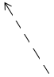
B
D
C

- The diagram above represents a feedback cycle. In general terms, B and C refer to the

  - modulator and effector.
  - receptor and response.
  - receptor and effector.
  - modulator and response.

- An appropriate modulator in this cycle would be the

  - medulla oblongata.
  - hypothalamus.
  - pituitary gland.
  - thyroid gland.
- The difference between white and grey matter within the brain is

  - the white matter is on the outside away from the nerve tracts, whilst the grey matter is on the inside.
  - the grey matter contains the unmyelinated nerve fibres and the white matter contains the cell bodies.
  - the white matter contains the dendrites of neurons, the grey matter contains the nerve fibres.
  - the grey matter contains the cell bodies of neurons and the white matter contains the myelinated nerve fibres.

- Voluntary motor nerve impulses travel from the motor cortex located in the

  - cerebellum, to the skeletal muscles.
  - frontal lobe of the cerebrum, to the skeletal muscles via the somatic efferent neurons.
  - parietal lobe of the cerebrum, to the skeletal muscles via the autonomic efferent neurons.
  - temporal lobe, to the smooth and cardiac muscles via the autonomic efferent neurons.

- The part of the human brain that regulates hunger, thirst and sleeping patterns is the

  - hypothalamus.
  - cerebrum.
  - cerebellum.
  - medulla oblongata.

- The anterior pituitary gland produces and secretes all of the following hormones except for

  - growth hormone.
  - thyroid stimulating hormone.
  - prolactin.
  - antidiuretic hormone.

Refer to the list below to answer the next question. This information shows some normal physiological changes in the human body.
A. Dilation of pupils
B. Increased heart rate
C. Increased secretion of saliva
D. Increased secretion from sweat glands
E. Dilation of blood vessels to the skeletal muscles
F. Decreased levels of adrenalin in blood

- Which of the changes in the above list would result from stimulation by the sympathetic division of the autonomic nervous system?

  - A, B, C and D
  - A, C, D and E
  - A, B, D and E
  - B, D, E and F
- An individual contracted a malarial parasite after a mosquito took a blood meal from them. Which of the following methods would describe how this disease was transmitted?

  - By contact
  - By a vector
  - By body fluids
  - By ingestion

- Which of the following is not an example of a non-specific defence?

  - Oily sebum contains substances that kill some bacteria.
  - The beating motion of cilia within the respiratory system.
  - Cerumen found in stomach juice kills most bacteria that are swallowed.
  - The vagina has acidic secretions that reduce growth of micro-organisms.

- The cerebrospinal fluid provides protection to the central nervous system by absorbing any shock to the head. The cerebrospinal fluid is found between the

  - cranial bones and cerebrum.
  - outer dura mater and the inner pia mater.
  - middle arachnoid and the outer dura mater.
  - inner pia mater and middle arachnoid.

- The following event and subsequent response that best describes what happens during antibody mediated immunity, would be the

  - T lymphocyte presents the antigen to the B lymphocyte; the B lymphocyte produces clones and memory cells.
  - B lymphocyte is activated by an antibody; the B lymphocyte produces clones and memory cells.
  - B lymphocyte is activated by an antigen; the B cells can become either a plasma, suppressor or memory cell.
  - B lymphocyte is presented with an antigen; the B lymphocyte may become a clone that secretes specific antibodies.

- Herd immunity is most easily achieved by providing

  - natural passive immunity.
  - artificial active immunity.
  - artificial passive immunity.
  - natural active immunity.

- Which of the following is true regarding a spinal reflex?

  - They occur under the conscious control of the cerebrum.
  - They are only learnt through repetition.
  - They are not spontaneous
  - They are regulated by positive feedback.

- Many micro-organisms produce antibiotic substances. Actinomycetes are bacteria that produce a substance that can penetrate a cell membrane and disrupt protein synthesis, stopping the unicellular organism from reproducing. This type of substance is referred to as an/a

  - antiviral drug.
  - narrow-entry antibiotic.
  - bactericidal antibiotic.
  - bacteriostatic antibiotic.

- Aerobic respiration is a chemical reaction that produces a number of waste products which are detected by different sensory receptors to maintain homeostasis. Those receptors that would be most sensitive to these wastes would be

  - osmoreceptors, chemoreceptors and pancreatic alpha cells.
  - peripheral and central chemoreceptors, and osmoreceptors.
  - thermoreceptors, osmoreceptors and pancreatic beta cells.
  - peripheral and central chemoreceptors.

The next two questions refer to the diagram below
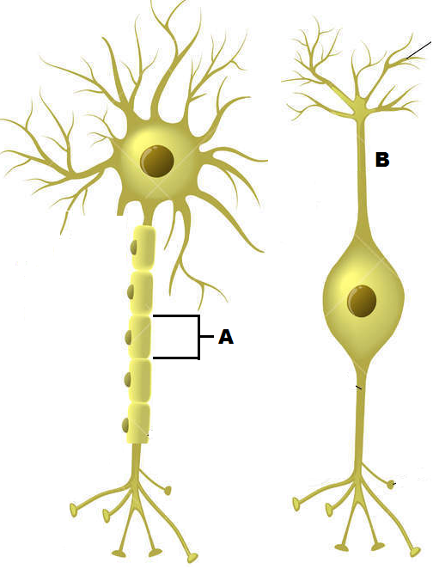
- The cell labelled A has the following function.

  - Forms the myelin sheath.
  - Provides a conducting surface.
  - Secretes neurotransmitters.
  - Speeds up hormonal impulses.

- The cell labelled B is a

  - sensory bipolar neuron.
  - sensory multipolar neuron.
  - motor bipolar neuron.
  - unipolar interneuron.
- The role of histamine is to

  - prevent clotting.
  - make the walls of the blood capillaries more permeable.
  - decrease the blood flow to the infected area.
  - attract thrombocytes to the infected area.

- Increasing the carbon dioxide concentration in the blood will

  - increase the pH of the blood.
  - incur hyperventilation.
  - stimulate a nervous impulse through the vagus nerve.
  - trigger a response from the chemoreceptors before a decrease in oxygen concentration.

- Glucagon will maintain blood glucose at homeostatic levels by

  - decreasing the production of glycogen.
  - increasing the formation of glycogen.
  - increasing the catabolism of glycogen.
  - increasing the anabolism of glycogen.

- Choose the best description of a bacteriophage.

  - A virus that reproduces within bacteria.
  - A bacterium that is resilient to viral infections.
  - Bacteria that are injected with a virus to produce insulin.
  - Bacterium that have a specific rod shape and flagella.

The following information relates to answer the next FOUR questions.
A patient has complained of the following symptoms to their doctor:
- Feeling a lack of energy
- Unexplained weight gain
- Feeling cold, even though the surrounding temperature is around 25^{ᵒ}C

In response, the doctor had the patient’s Thyroid Stimulating Hormone (TSH) levels tested over five consecutive days. The patient’s results, measured in milli-international units per litre (mlU/L), can be seen in the table below.

Day | 1 | 2 | 3 | 4 | 5
TSH concentration (mlU/L) | 2.0 | 2.5 | 2.9 | 2.8 | 2.3

A normal range is between 0.4 and 4.0 mlU/L.

- The mean TSH concentration in the patient’s bloodstream over the five days was

  - 2.0
  - 2.3
  - 2.5
  - 2.6
- The range and median for the patient’s TSH level was

  - 2.0 to 2.9 with a median of 2.6
  - 2.1 to 2.9 with a median of 2.3
  - 2.0 to 2.1 with a median of 2.9
  - 2.0 to 2.9 with a median of 2.5

- The percentage change in the patient’s TSH concentration level from the first day to the third day was a

  - 15% increase.
  - 15% decrease.
  - 45% increase.
  - 45% decrease.

- Based on the information the patient provided, the disease the doctor was most likely checking for was

  - type 1 diabetes
  - type 2 diabetes
  - hypothyroidism
  - hyperthyroidism

- Complete the following sentence by choosing the correct sequence of words.
Once a hormone has produced the required effect, it needs to be broken down. This mostly occurs in the _______ and the ________. This process is known as ___________.

  - target cells; liver; enzyme amplification
  - kidney; liver; negative feedback
  - target cells; kidney; hormone clearance
  - liver; kidney; hormone clearance

- Choose the best description of a virus.

  - A protein coat surrounding either DNA or RNA.
  - A protein coat with both RNA and DNA.
  - A non-living entity that causes disease.
  - An organism that invades and multiplies within bacteria.

- A soccer player, having received a blow to the head, has come off the field without a bleed. He complains of having blurred vision in both eyes. The most likely point of contact would have been the

  - frontal lobe
  - occipital lobe
  - the left-hand side of the head
  - the right-hand side of the head
Section Two: Short answer 50% (100 Marks)
This section has eight (8) questions. Answer all questions. Write your answers in the spaces provided.
Spare pages are included at the end of this booklet. They can be used for planning your responses and/or as additional space if required to continue an answer.
  - Planning: If you use the spare pages for planning, indicate this clearly at the top of the page.
  - Continuing an answer: If you need to use the space to continue an answer, indicate in the original answer space where the answer is continued, i.e. give the page number. Fill in the number of the question(s) that you are continuing to answer at the top of the page.

Suggested working time: 90 minutes.
Question 31 (12 marks)
The diagram below shows a section of skin with a number of parts that are involved in maintaining homeostasis.
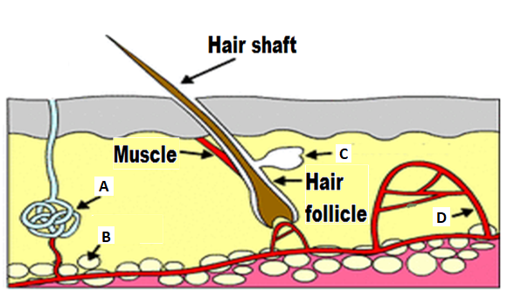
- Identify the parts in the above diagram

A ___________________________________

B ___________________________________

D ___________________________________ (3 marks)

- There are two classifications of glands in the body. State the type of gland/s that can be seen in the diagram above and explain why they are classified into their particular group.

____________________________________________________________________

____________________________________________________________________

____________________________________________________________________
(2 marks)
- A marathon runner completes a race in hot weather. By the end of the race he is sweating, breathing heavily, feels thirsty and his skin is red and hot.

Complete the following table to summarise why the runner experiences the symptoms stated. The first row has been completed as an example. (7 marks)

Symptoms | Stimulus | Receptor | Modulator | Effector | Response
Sweating | Increased body temperature | Thermoreceptor | Hypothalamus | Sweat gland | Sweat released onto surface of the skin.
Breathing heavily |  | Chemoreceptor |  | Diaphragm and intercostals | Increased rate and depth of breathing
Thirsty |  |  | Hypothalamus |  | Conscious decision to have a drink
Red and hot skin | Increased body temperature | Thermoreceptor | Hypothalamus

Question 32 (17 marks)
Scientists wanted to test the hypothesis that neurotransmitters released from a specific group of nerve cells (called the NTS) found within the medulla oblongata, increases long term memory retention in humans. The NTS are ascending tracts that link to the amygdala, which is a part of the brain responsible for emotional memories.

To investigate this theory, scientists exposed two rats to inhibitory avoidance training. To do this experiment, each rat was tested separately. They were placed into a box, facing a closed sliding door. The box was well lit with white light. Once the rat turned away from the door, the door was opened, allowing free access to a darker, secluded box. The moment the rat turned to face the open door, a timer was started and once the rat had completely entered the dark room, the door was closed and the time was stopped and recorded. Upon entering the dark room, a footshock (weak electrical current passed into the rat’s foot via the floor) was administered. Immediately after the footshock, the rat was removed from the dark box and given a dose of lignocaine into the NTS. Lignocaine is an anaesthetic that binds to sodium-gated channels and prevents them from opening.

Memory for the footshock training is assessed by retesting the rat from 24 to 96 hours later. In this test, the rat is placed in the well-lit box as before, the door is opened once the rat looks away and the time taken for the rat to enter the dark box where the footshock was received earlier is recorded. The time recorded is used as an indicator of the level of memory retention.
The results from the experiment can be seen below.
Time passed since rat given lignocaine  (hours) | Time passed before rat entered dark room (seconds)
Time passed since rat given lignocaine  (hours) | Rat not given lignocaine | Rat given lignocaine
12 | 180 | 181
24 | 150 | 152
36 | 135 | 132
48 | 138 | 130
60 | 152 | 130
72 | 220 | 125
84 | 260 | 120
96 | 300 | 118

- Identify the
  - Independent variable ________________________________________________
  - Dependent variable _________________________________________________
(2 marks)

- State why the scientist provided a rat with inhibitory avoidance training, but did not administer lignocaine.
________________________________________________________________________________________________________________________________________________________________________________________________________________________
(2 marks)

- Plot a graph of the information contained in the table. (A spare graph has been provided on page 33 if required). (6 marks)

- What conclusions can be drawn from the results?
________________________________________________________________________________________________________________________________________________________________________________________________________________________________________________________________________________________________
(2 marks)

- Name the process that would have been inactivated by the lignocaine in the NTS and explain why the post-synaptic knobs in the amygdala would not have been stimulated.
________________________________________________________________________________________________________________________________________________________________________________________________________________________________________________________________________________________________________________________________________________________________________________________________________________________________________________________________________________________________________________________
________________________________________________________________________________________________________________________________________________
________________________________________________________________________________________________________________________________________________
(5 marks)

Question 33 (17 marks)
Refer to the diagram below and answer the questions that follow.
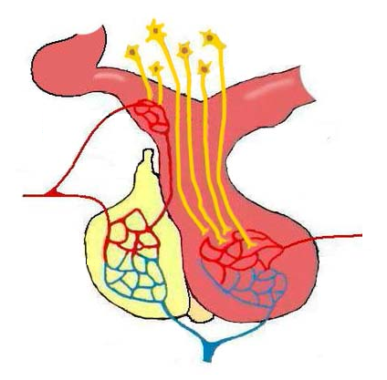
C
D
E
B
A

- Identify the parts labelled C, D and E in the diagram on the previous page.
C ______________________________________
D ______________________________________
E ______________________________________ (3 marks)

- Explain the different methods the hypothalamus uses to stimulate parts C and E, so they can release their respective chemicals.
________________________________________________________________________________________________________________________________________________________________________________________________________________________________________________________________________________________________________________________________________________________________________________________________________________________
________________________________________________________________________________________________________________________________________ (4 marks)
- Using the space below, draw a sequence diagram that shows how the organs shown in the diagram above regulate the water concentration in the bloodstream. (6 marks)

- The diagram below indicates two endocrine tissues labelled D and E. In the boxes provided for EACH tissue (D – E):
  - Name ONE hormone secreted by that tissue
  - State ONE principal action of that named hormone on the target tissue
Tissue D
- _______________________________________________ (1 mark)
- ______________________________________________________________________________________________________________
(1 mark)
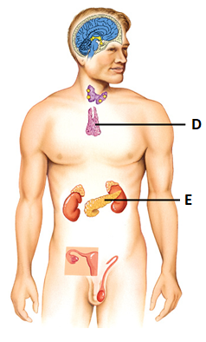
Tissue E
- _______________________________________________ (1 mark)
- ______________________________________________________________________________________________________________
(1 mark)

Question 34 (13 marks)
Nicole is highly allergic to shellfish and if she accidentally consumes any product with shellfish in it, she can go into anaphylactic shock. Symptoms of anaphylaxis include a red and hot rash, throat or tongue swelling, difficulty breathing, vomiting and low blood pressure. In the event she does go into anaphylactic shock, she carries an EpiPen®, which can provide her with a dose of epinephrine (adrenaline) and alleviate the symptoms.

- Name the protective reflex that occurs as a result of the anaphylactic shock and describe how it occurs.

________________________________________________________________________________________________________________________________________ (2 marks)

- Describe how the adrenaline would make breathing easier.
________________________________________________________________________________________________________________________________________
(1 mark)

- Adrenaline is classified as an amine hormone. Explain how this hormone acts on a cell and causes the cell to produce a particular protein.
________________________________________________________________________________________________________________________________________________________________________________________________________________________________________________________________________________
________________________________________________________________________________________________________________________________________
(3 marks)

- An adult EpiPen® typically injects 0.3mg of adrenaline. If the device was to inject anymore, it would not have any further effect. Explain why.
________________________________________________________________________________________________________________________________________________________________________________________________________________________________________________________________________________
________________________________________________________________________________________________________________________________________________________________________________________________________________________________________________________________________________
________________________________________________________________________________________________________________________________________
(3 marks)

- Complete the following table to distinguish between the specific effects of the parasympathetic and sympathetic divisions.
 | Parasympathetic | Sympathetic
Specific effect on the digestive system
Specific effect on the bladder

(4 marks)

Question 35 (12 marks)
Refer to the diagram below and answer the questions that follow.
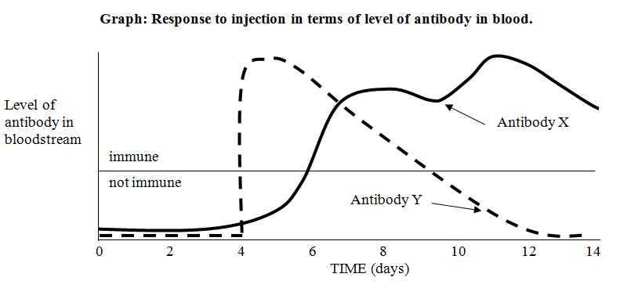

- On what day/s were the injections given which caused the change in the level of

(i) Antibody X: ____________________________________________

(ii) Antibody Y: ____________________________________________
(2 marks)

- Describe a situation in which a person might receive an injection such as the one which led to the change in the level of antibody Y.

____________________________________________________________________
____________________________________________________________________
____________________________________________________________________
(1 mark)
- Describe three (3) ways antibodies provide protection in the body.

________________________________________________________________________________________________________________________________________________________________________________________________________________________________________________________________________________
________________________________________________________________________________________________________________________________________
(3 marks)
- The level of both antibodies decline after some time. Explain why they decline and why the level of antibody X declined more slowly than the level of antibody Y.

________________________________________________________________________________________________________________________________________________________________________________________________________________________________________________________________________________
________________________________________________________________________________________________________________________________________
(3 marks)

- In order to ensure vaccines are safe to use on the general population, they are extensively trialled. Name and briefly describe one potential problem that could occur when providing a vaccine.

________________________________________________________________________________________________________________________________________________________________________________________________________________________________________________________________________________
(2 marks)
- When a new vaccine is first introduced, follow up studies are required to determine how long the vaccine will provide protection for. State the name given to this type of investigation.

____________________________________________________________________
(1 mark)

Question 36 (15 marks)

A freestyle diver is someone who swims under water without any breathing apparatus, to the deepest possible depth, before returning to the surface. In an effort to stay under water for as long as possible, they will hyperventilate. The danger of this sport is that the diver could lose consciousness and drown. This consequence is referred to as “blacking out”.
The two graphs below show the relationship between the levels of oxygen and carbon dioxide within a freestyle diver’s bloodstream. One of the graphs shows what happens to the gas levels without hyperventilating. The other shows what happens to the gas levels when the diver hyperventilates before diving. Study these two graphs and answer the questions that follow.
Graph 1
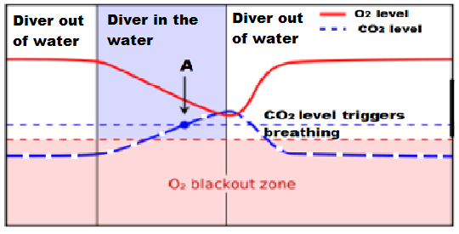
Graph 2
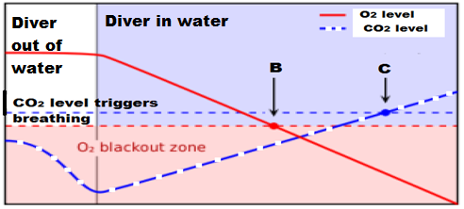

- State which of the two graphs shows what happens to the gas levels when the diver has hyperventilated. Explain your answer.
____________________________________________________________________________________________________________________________________________________________________________________________________________
(2 marks)
- Looking at the points indicated by the letters A, B and C on the graphs above, state how the diver’s body is responding and what the diver is doing
____________________________________________________________________
____________________________________________________________________
____________________________________________________________________
____________________________________________________________________
____________________________________________________________________
____________________________________________________________________
(3 marks)
- One of the graphs above shows where the diver has reached the surface and taken a breath. Circle and clearly label this area on the relevant graph above, using the letter D. (1 mark)

- Hyperventilating can be brought on through physical stress. To help someone recover from hyperventilation, they can breathe into and out of a paper bag a number of times. Explain why this technique prevents someone from losing consciousness and allows them to regain control over their breathing rate.

____________________________________________________________________________________________________________________________________________________________________________________________________________________________________________________________________________________________________________________________________________________________________________________________________________________________________________________________________________________________
(5 marks)

- Hyperventilation can lead to respiratory alkalosis. This disorder can bring about a decrease in potassium and calcium levels within the bloodstream, which then leads to uncontrollable muscle cramping.

Complete the following table to summarise how the endocrine system would respond to the decrease in potassium and calcium.

Gland | Hormone name | Hormone level raised or decreased? | Target organ/s | Main effects
 |  |  |  | Increases level of calcium in the blood
 |  |  |  | Decreases removal of potassium from the blood
(4 marks)

Question 37 (14 marks)
- Complete the diagram below of a reflex arc, by drawing in and clearly labelling the missing structures/components. The neuron leading to the effector has already been drawn for you. (3 marks)

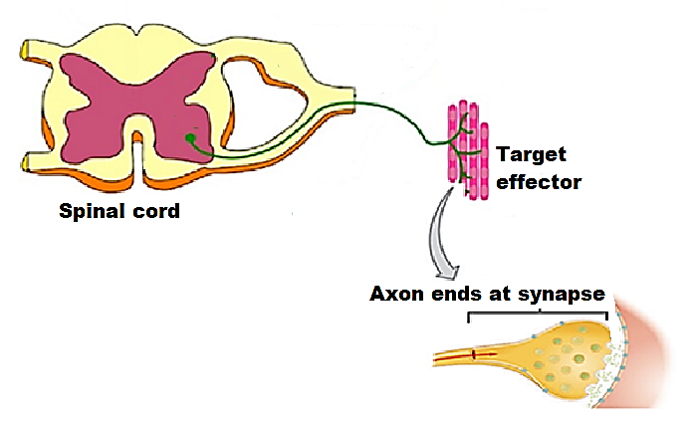
(Skeletal muscle)
- To make it easier to describe the various functions of the peripheral nervous system, it has been classified into divisions and subdivisions.

Complete the following table to classify and describe the neural pathway shown in the diagram on the previous page.
Division(s) | Description of division(s) | Subdivision(s) | Description of subdivision(s) | Name of neurotransmitter(s) released
(5 marks)

- Below is an action potential graph, showing the outcome from two different stimuli on the same neuron.
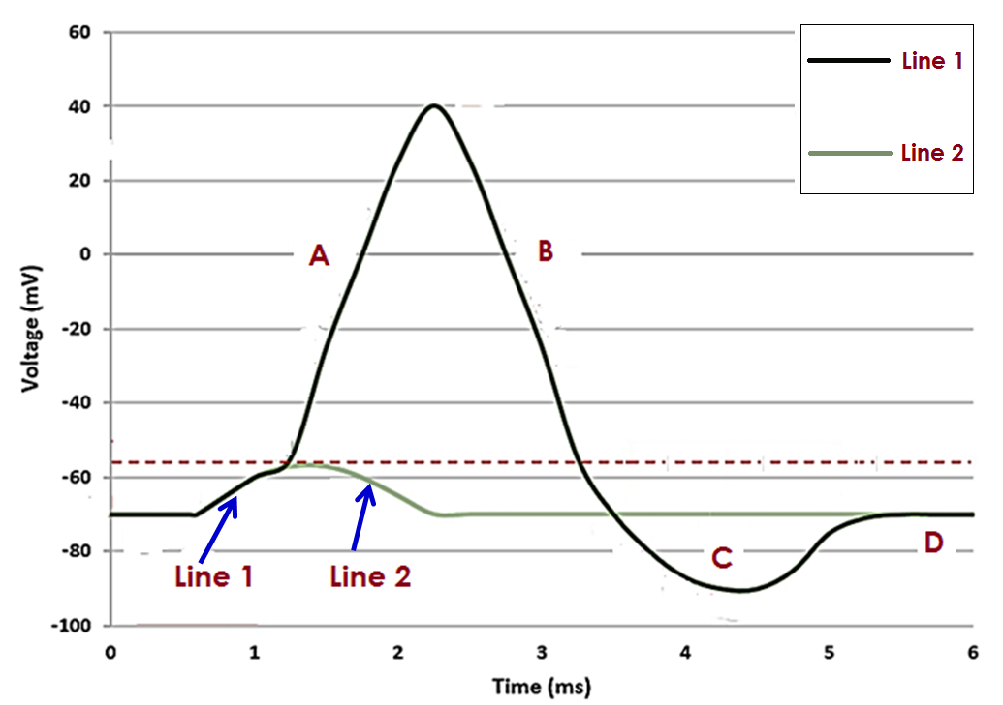
- The first stimulus resulted in Line 1 and the second stimulus results in Line 2, as shown on the diagram on the previous page.

Describe what occurred to result in Line 2 and state one reason why this has happened.
________________________________________________________________________________________________________________________________________________________________________________________________________________________________________________________________________________________________________________________________________________________________________________________________________________________
(2 marks)
- Describe the events occurring at the sections labelled A and C.

Section A
Section C
(4 marks)

Section Three: Extended answer 20% (40 Marks)
This section contains three (3) questions. You must answer two (2) questions. Make sure you clearly indicate which question you are answering and write your answers in the space provided.
Spare pages are included at the end of this booklet. They can be used for planning your responses and/or as additional space if required to continue an answer.
- Planning: If you use the spare pages for planning, indicate this clearly at the top of the page.
  - Continuing an answer: If you need to use more space to continue an answer, indicate in the original answer space where the answer is continued, i.e. give the page number. Write the number of the question(s) that you are continuing to answer at the top of the additional space page.

Responses could include clearly labelled diagrams with explanatory notes; lists of points with linking sentences; clearly labelled tables and graphs; and annotated flow diagrams with introductory notes.
Suggested working time: 40 minutes.
_____________________________________________________________________________

Question 38 (20 marks)
- Tuberculosis is a disease caused by a bacterium which invades and replicates inside the cells of their host. Subsequently, the body responds by disrupting the intracellular phase of the bacterial infection.

State the name of the specific immune response that would be triggered for this type of bacteria and explain the events that would occur to eradicate the disease in the short term and prevent its return in the future.
(10 marks)

- Jacinta travels from Australia to Siberia for a three-week skiing holiday and chance to see Lake Baikal, the world’s deepest lake. Even though she was aware and well prepared for the difference in climate, Jacinta really notices the cold whenever she is outside.

- Name and describe the role of two hormones that would be released to regulate Jacinta’s body temperature during her stay in Siberia. Include in your answer, how the release of these hormones are controlled.
(6 marks)

- Outline two behavioural responses that will be useful to employ and describe how these responses will help her stay warm.
(4 marks)

Question 39 (20 Marks)
Multiple sclerosis (MS) is an autoimmune disease, where T lymphocytes attack and destroy oligodendrocytes within the central nervous system. These cells serve the same function as the Schwann cell of the peripheral nervous system. Specific symptoms of this disease can include a decreased ability to detect stimuli, speak or swallow and loss of fine muscle coordination.
- Compare and contrast the transmission of a nerve impulse along an unmyelinated and myelinated fibre. (9 marks)

- Explain how an individual has the ability to distinguish stimuli of a different intensity, yet someone with MS cannot. (6 marks)

- Parturition (child-birth) involves the actions of the nervous and endocrine system. Describe three differences between the actions of these two systems during parturition and explain why it is possible for a woman with MS to still give birth, even though her muscles are weakened by the damaged motor neurons.
(5 marks)

Question 40 (20 marks)
- To get a correct diagnosis on one of his patients, the doctor has requested a blood test to be performed. The patient was given strict instructions to fast (not consume any food) for at least six hours before getting the blood test.

Outline what is happening to the patient’s blood glucose levels over the fasting period and describe, in detail, how the levels are regulated in the body.
(12 marks)

- An individual’s basal metabolic rate can be affected by an over or under active thyroid gland.

Identify and contrast these two conditions and despite having so many differences, explain why they both cause fatigue.
(8 marks)

Question number: ________________
______________________________________________________________________________________________________________________________________________________________________________________________________________________________________________________________________________________________________________________________________________________________________________________________________________________________________________________________________________________________________________________________________________________________________________________________________________________________________________________________________________________________________________________________________________________________________________________________________________________________________________________________________________________________________________________________________________________________________________________________________________________________________________________________________________________________________________________________________________________________________________________________________________________________________________________________________________________________________________________________________________________________________________________________________________________________________________________________________________________________________________________________________________________________________________________________________________________________________________________________________________________________________________________________________________________________________________________________________________________________________________________________________________________________________________________________________________________________________________________________________________________________________________________________________________________________________________________________________________________________________________________________________________________________________________________________________________________________________________________________________________________________________________________________________________________________________________________________________________________________________________________________________________________________________________________________________________________________________________________________________________________________________________________________________________________________________________________________________________________________________________________________________________________________________________________________________________________________________________________________________
Question number: ________________
______________________________________________________________________________________________________________________________________________________________________________________________________________________________________________________________________________________________________________________________________________________________________________________________________________________________________________________________________________________________________________________________________________________________________________________________________________________________________________________________________________________________________________________________________________________________________________________________________________________________________________________________________________________________________________________________________________________________________________________________________________________________________________________________________________________________________________________________________________________________________________________________________________________________________________________________________________________________________________________________________________________________________________________________________________________________________________________________________________________________________________________________________________________________________________________________________________________________________________________________________________________________________________________________________________________________________________________________________________________________________________________________________________________________________________________________________________________________________________________________________________________________________________________________________________________________________________________________________________________________________________________________________________________________________________________________________________________________________________________________________________________________________________________________________________________________________________________________________________________________________________________________________________________________________________________________________________________________________________________________________________________________________________________________________________________________________________________________________________________________________________________________________________________________________________________________________________________________________________________________________
Question number: ________________
______________________________________________________________________________________________________________________________________________________________________________________________________________________________________________________________________________________________________________________________________________________________________________________________________________________________________________________________________________________________________________________________________________________________________________________________________________________________________________________________________________________________________________________________________________________________________________________________________________________________________________________________________________________________________________________________________________________________________________________________________________________________________________________________________________________________________________________________________________________________________________________________________________________________________________________________________________________________________________________________________________________________________________________________________________________________________________________________________________________________________________________________________________________________________________________________________________________________________________________________________________________________________________________________________________________________________________________________________________________________________________________________________________________________________________________________________________________________________________________________________________________________________________________________________________________________________________________________________________________________________________________________________________________________________________________________________________________________________________________________________________________________________________________________________________________________________________________________________________________________________________________________________________________________________________________________________________________________________________________________________________________________________________________________________________________________________________________________________________________________________________________________________________________________________________________________________________________________________________________________________
Question number: ________________
______________________________________________________________________________________________________________________________________________________________________________________________________________________________________________________________________________________________________________________________________________________________________________________________________________________________________________________________________________________________________________________________________________________________________________________________________________________________________________________________________________________________________________________________________________________________________________________________________________________________________________________________________________________________________________________________________________________________________________________________________________________________________________________________________________________________________________________________________________________________________________________________________________________________________________________________________________________________________________________________________________________________________________________________________________________________________________________________________________________________________________________________________________________________________________________________________________________________________________________________________________________________________________________________________________________________________________________________________________________________________________________________________________________________________________________________________________________________________________________________________________________________________________________________________________________________________________________________________________________________________________________________________________________________________________________________________________________________________________________________________________________________________________________________________________________________________________________________________________________________________________________________________________________________________________________________________________________________________________________________________________________________________________________________________________________________________________________________________________________________________________________________________________________________________________________________________________________________________________________________________
Question number: ________________
______________________________________________________________________________________________________________________________________________________________________________________________________________________________________________________________________________________________________________________________________________________________________________________________________________________________________________________________________________________________________________________________________________________________________________________________________________________________________________________________________________________________________________________________________________________________________________________________________________________________________________________________________________________________________________________________________________________________________________________________________________________________________________________________________________________________________________________________________________________________________________________________________________________________________________________________________________________________________________________________________________________________________________________________________________________________________________________________________________________________________________________________________________________________________________________________________________________________________________________________________________________________________________________________________________________________________________________________________________________________________________________________________________________________________________________________________________________________________________________________________________________________________________________________________________________________________________________________________________________________________________________________________________________________________________________________________________________________________________________________________________________________________________________________________________________________________________________________________________________________________________________________________________________________________________________________________________________________________________________________________________________________________________________________________________________________________________________________________________________________________________________________________________________________________________________________________________________________________________________________________
Additional working space
Question number: ________________
__________________________________________________________________________________________________________________________________________________________________________________________________________________________________________________________________________________________________________________________________________________________________________________________________________________________________________________________________________________________________________________________________________________________________________________________________________________________________________________________________________________________________________________________________________________________________________________________________________________________________________________________________________________________________________________________________________________________________________________________________________________________________________________________________________________________________________________________________________________________________________________________________________________________________________________________________________________________________________________________________________________________________________________________________________________________________________________________________________________________________________________________________________________________________________________________________________________________________________________________________________________________________________________________________________________________________________________________________________________________________________________________________________________________________________________________________________________________________________________________________________________________________________________________________________________________________________________________________________________________________________________________________________________________________________________________________________________________________________________________________________________________________________________________________________________________________________________________________________________________________________________________________________________________________________________________________________________________________________________________________________________________________________________________________________________________________________________________________________________________________________
Additional working space
Question number: ________________
__________________________________________________________________________________________________________________________________________________________________________________________________________________________________________________________________________________________________________________________________________________________________________________________________________________________________________________________________________________________________________________________________________________________________________________________________________________________________________________________________________________________________________________________________________________________________________________________________________________________________________________________________________________________________________________________________________________________________________________________________________________________________________________________________________________________________________________________________________________________________________________________________________________________________________________________________________________________________________________________________________________________________________________________________________________________________________________________________________________________________________________________________________________________________________________________________________________________________________________________________________________________________________________________________________________________________________________________________________________________________________________________________________________________________________________________________________________________________________________________________________________________________________________________________________________________________________________________________________________________________________________________________________________________________________________________________________________________________________________________________________________________________________________________________________________________________________________________________________________________________________________________________________________________________________________________________________________________________________________________________________________________________________________________________________________________________________________________________________________________________________
Spare graph for question 32

References
Question 18-19
Image retrieved 26 September 2017 from
https://www.dreamstime.com/stock-illustration-types-neurons-basic-neuron-unipolar-pseudo-unipolar-neuron-bipolar-multipolar-neuron-cell-body-different-image52092345#
Under the Dreamstime license

Question 31
Image retrieved 27 September 2017 from
http://gcsebiologycore.blogspot.com.au/2014/09/homeostasis.html
Under the Common Creative license

Question 33
Image retrieved 30 April from
https://commons.wikimedia.org/wiki/File:Pituitary_gland_et_vessel.jpg
Under the Free Images license

Question 33 (d)
Image retrieved 26 October 2017 from
www.thinglink.com/scene/497504539574796289
Under the Common Creative license

Question 36
Image retrieved 27 September 2017 from
http://tecidc.com/go-pro/dive-theory-english/idc-physiology/
Under the Free Images license

Question 37
Image retrieved 3 October 2017 from
https://www.thinglink.com/scene/647049245123149824

Question 37
Image retrieved 30 April 2018 from
http://tadpoles.org.uk/home/schools/a-level/nerve-impulses/

